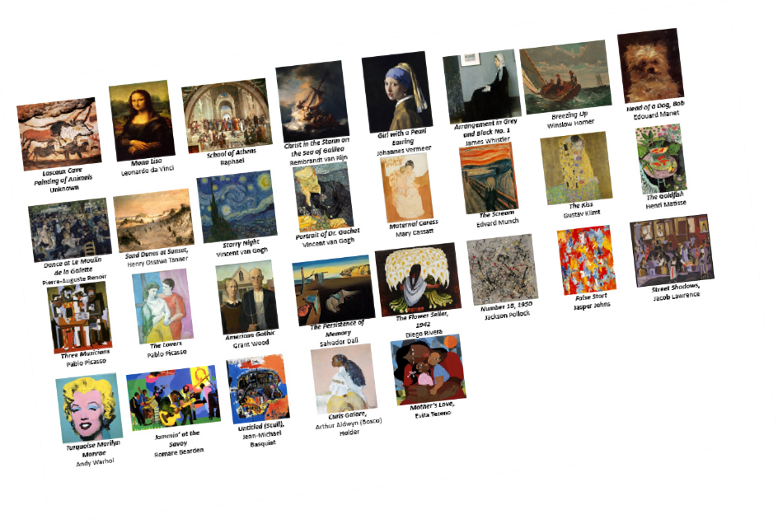
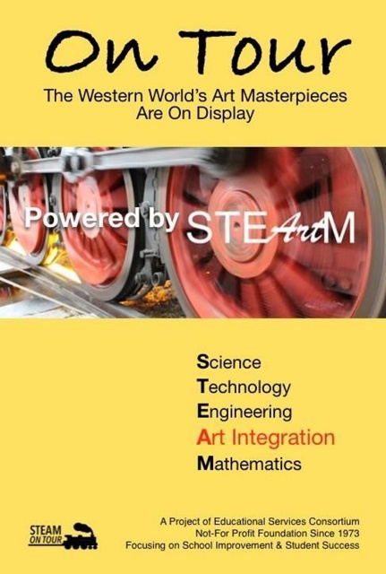
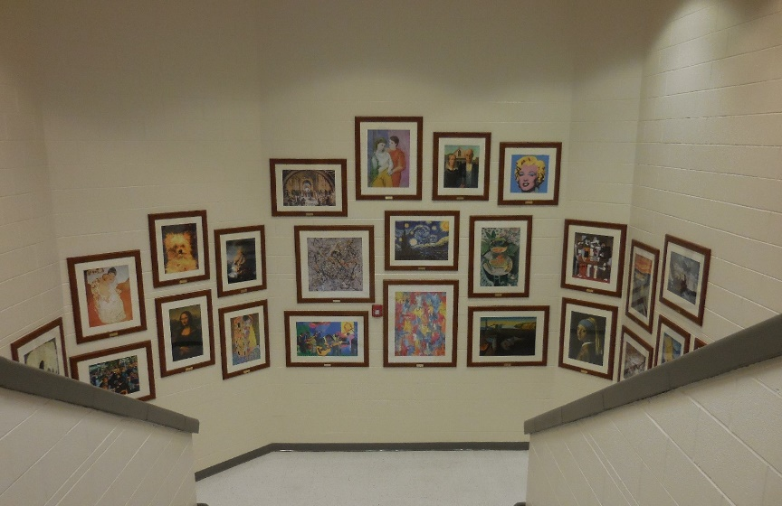
On Tour

www.naturalforces.org

Proudly Made in the USA

The “On Tour” STEAM Art Integration Program is an amazing tool for teachers promoting student achievement. Recent national research articles have demonstrated a direct link between significant increases in student achievement and participation in art integration programs.
Teachers can customize and distribute the content to best meet the needs of any group of students.
“On Tour” is a collection of the Western World’s great paintings reflecting fifteen art periods/styles. “On Tour” focuses on Science, Technology, Engineering, Art (includes design and humanities) and Mathematics (STEAM). Each set includes 24 museum quality paintings/frames and tour guide books with unlimited duplication rights along with STEAM questions related to each painting. The program is designed to encourage individual students, team of students or entire classes to engage in STEAM learning activities depending on the teacher’s intent.

Our expanded set of 29 paintings includes added emphasizes on the contributions of Black Artists.

Send PO:
Educational Services Consortium (ESC)
4980 Hollystone Lane
Tallahassee, FL 32312
850-363-3814
Costs: $ 7,200.00 for the 29 painting STEAM On Tour Set
Proudly Made in the USA
The prices noted above are subject to change without notice due to rising costs.

Ask for Kathy Snyder, CFO of ESC.
ESC (EIN 23-7318045) is an all-volunteer organization serving education continually since 1973.



ON TOUR
Click to Click to Click to
add photo add photo add photo
Click to
add photo
Click to
add photo

On Tour is a collection of paintings introducing students to the world’s most famous artists. These paintings reflect sig- nificant periods and styles in the history of Western art.
The paintings were selected to appeal to students while providing an introduction to art history, knowledge, and appreciation.
The On Tour book will provide students a glimpse of the artists who produced these paintings and the world in which they lived.

Powered By:
Science Technology Engineering
Arts, Design & Humanities
Mathematics
Quality of Frames and Contents:

Program Contents:

Framed fine art paintings
- 2 bound On Tour books, color edition
- 1 CD allowing the school to print additional books as needed, color edition
Program Features:
- On Tour is designed to complement STEAM Standards.

- A teacher may take an entire class On Tour using one book as a teacher’s guide.

- A teacher may provide an individual student with a book to be used as an independent study guide.

All frames are custom built to last using real wood, and a long lasting mat material.
Our frames use safety glass and are supported by backing with professional hangers and wire ready for display.
All frames have brass identification plates and are numbered to compliment the guide book.

Proudly Made in the USA

